**Creating a DSN for an Access Database**

To create a DSN for an Access database:

1. Open the Windows Control Panel.

2. Double-click **Administrative Tools**.

3. Double-click **Data Sources**.

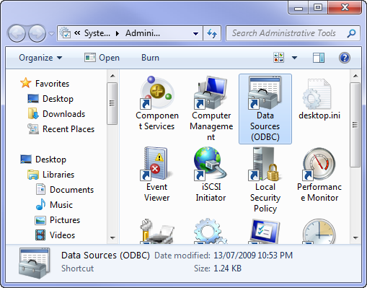

The ODBC Data Source Administrator dialog box opens.

**Note:**   For IHS Harmony, you must use the 32-bit version of the ODBC Administrator Tool. If you are running a 64-bit version of Windows, the 64-bit version of the ODBC Data Source Administrator is located at **C:\Windows\SysWOW64\odbcad32.exe**.

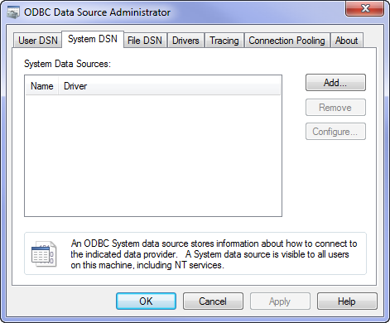

4. Click the **User DSN** tab (for a computer used by only one user), or **System DSN** tab (for a computer used by multiple users); then click **Add...**.

The Create New Data Source dialog box opens.

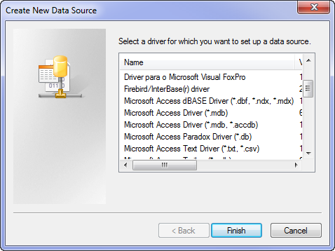

5. Select **Microsoft Access Driver** (*.mdb); then click **Finish**.

The ODBC Microsoft Access Setup dialog box opens.

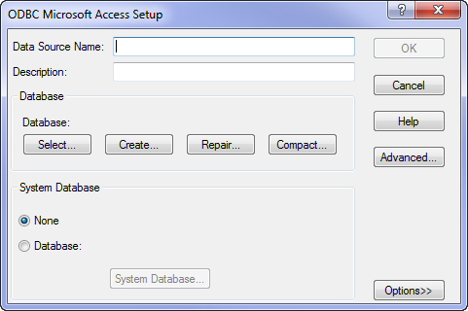

6. Enter a Data Source Name; then click **Select...**.

The Select Database dialog box opens.

**Note:**   We recommend that you give your DSN a name that you can easily recognize, as you will need to select the Data Source Name from a list whenever you open your database in Fekete's Database Connection tool.

7. Browse to the drive and folder where your Microsoft Access Database is located.

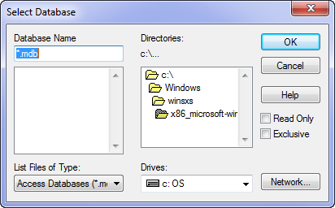

8. Select the database; then click **OK**.

Your Access database DSN is now created, and is ready for use by the Fekete Database Connection Tool.